Shopping Malls in Legazpi City

* SM Legazpi

Location: Zone 9 Imelda Roces Ave, Legazpi City, 4500 Albay

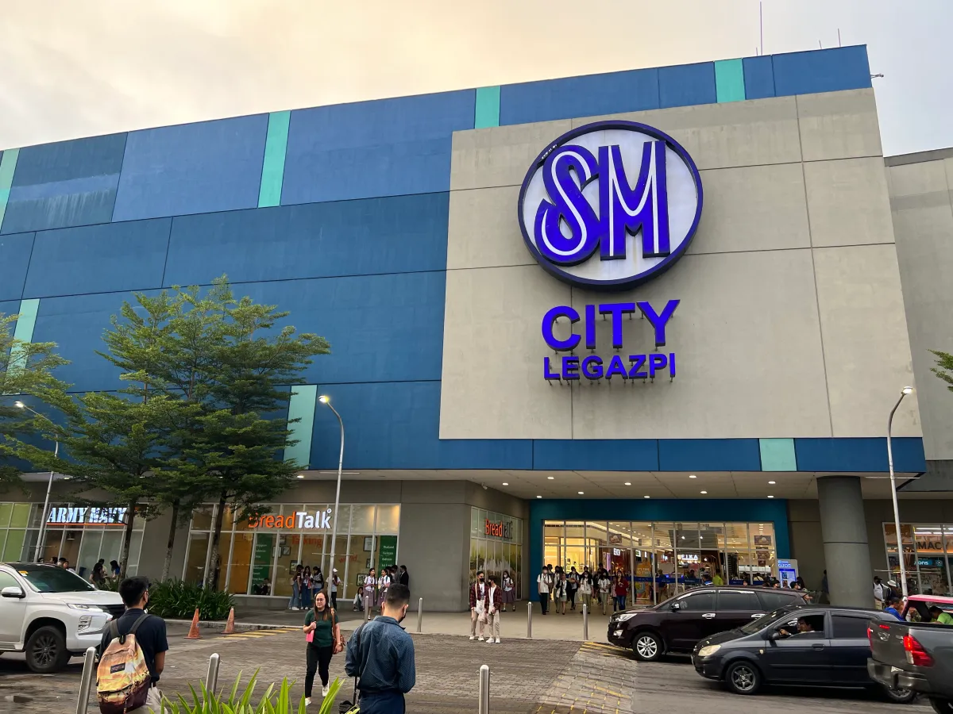

* Ayala Malls Legazpi

Location: Rizal Street, Corner Quezon Ave, Brgy. Capantawan, Legazpi City, 4500 Albay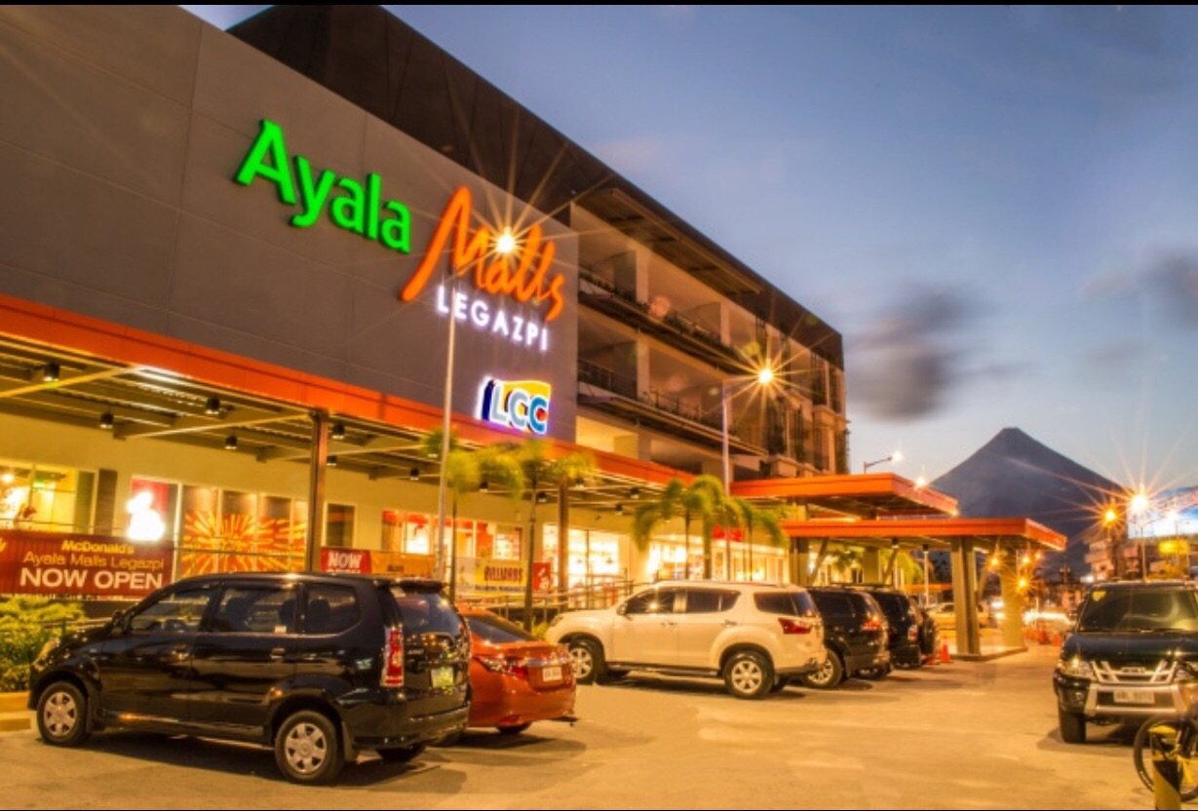

* Yashano Mall

Location: Terminal Road 1 Corner, F. Imperial St, Legazpi Port District, Legaspi, Albay

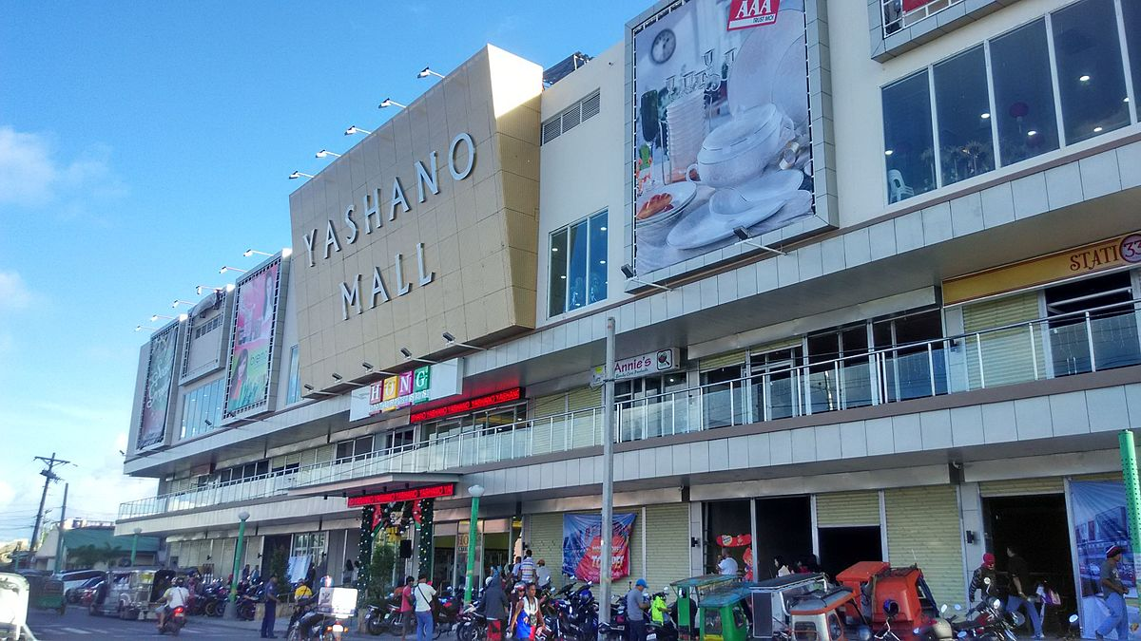

* Pacific Mall

Location: 4PWX+3VP, Landco Business Park, F. Imperial St, Legazpi Port District, Legazpi City, 4500 Albay

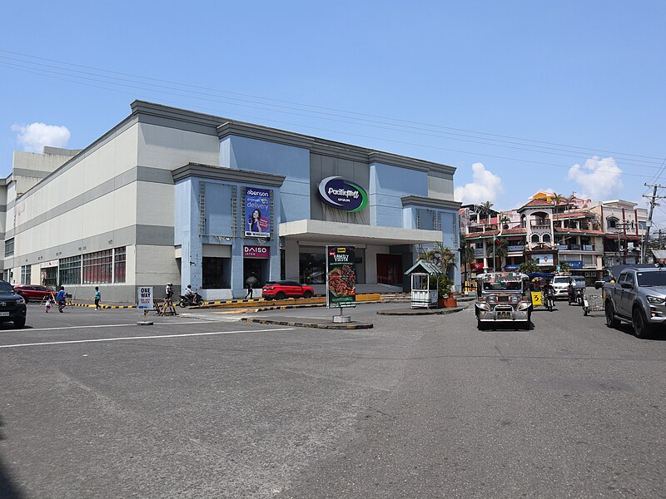

* LCC Mall Legazpi

Location: Jose P. Rizal Street, 4500 Legazpi, Albay

